Bram 24.11.2023

Manuscript provided for Powder Metallurgy
Field assisted sintering of Nd-Fe-B magnets with tailored anisotropic magnetic properties
M. Keszler¹, I. Radulov^{2,3}, F. Maccari³, T. Mutuk^{1,4}, T.P. Mishra¹, , M. Krengel⁵, O. Guillon^{1,6}, O. Gutfleisch³, M. Bram^{1,7}

1) Forschungszentrum Jülich, Institute of Energy and Climate Research, IEK-1: Materials Synthesis and Processing, 52425 Jülich, Germany.
2) Fraunhofer Research Institution for Materials Recycling and Resource Strategies IWKS, 63457 Hanau, Germany.
3) Technical University of Darmstadt, Institute for Materials Science, Functional Materials, 64287 Darmstadt, Germany.
4) Ondokuz Mayis University, Department of Metallurgical and Material Engineering, 55139, Atakum, Samsun, Turkey.
5) M. Krengel, Wilo SE, Magnetprototyping & Development Magnetic Materials, 44263 Dortmund, Germany.
6) Jülich Aachen Research Alliance, JARA-FIT, 52425 Jülich, Germany.
7) Ruhr University Bochum, Institute for Materials, 44801 Bochum, Germany.

Abstract
Field assisted sintering technologies like spark plasma sintering (FAST/SPS) or flash spark plasma sintering (Flash SPS) are attractive alternative methods for the processing of nanocrystalline Nd- Fe-B magnets with well-pronounced anisotropic magnetic properties. In both cases, a load is applied on a pre-compacted or pre-sintered sample, followed by pre-heating in suitable designed tools. Hot deformation will be done by either increase of the load (FAST/SPS) or by applying a well-defined power pulse (Flash SPS) leading to deformation and densification of the magnet in seconds. Compared to established processing of anisotropic magnets via hot pressing with subsequent die-upsetting, field assisted sintering technologies introduce the possibility of electroplasticity as an additional deformation mechanism. This mechanism has the potential to improve the magnetic properties through the fine-tuning of the microstructure. Our results reveal that the kind of pre-heating of the sample before applying the load/the power pulse plays a crucial role for tailoring grain size and grain aspect ratio, both being the key for well-pronounced anisotropic magnetic properties. For better understanding of the relationship between processing parameters, microstructure and resulting magnetic properties, systematic parameter studies have been done for both technologies in the present work. As final conclusion, both technologies are benchmarked with respect to established hot deformation technologies.

1. Introduction
Nd-Fe-B magnets play an important role in our daily life due to their widespread application in wind turbines, electric vehicles, hybrid electric vehicles, e-bikes, consumer goods, computers and green energy technologies [Sugimoto 2011, Gutfleisch 2011]. The weight of magnets in these applications varies from tons down to several grams [Yang 2017]. The preference for using Nd-Fe-B magnets is derived from these magnets having the highest energy-product (BH)_{max} at room temperature (theoretical 512 kJ⋅m⁻³) among all permanent magnet materials currently available on the market. Processing of Nd-Fe-B magnets is traditionally based on powder metallurgy. There are two main processing routes established, which differ in the kind of starting powder and either result in microcrystalline or nanocrystalline magnets.

For the manufacturing of microcrystalline magnets, powder production starts from melting and strip casting the alloy [Yang 2017, Gutfleisch 2000]. The produced flakes are comminuted by hydrogen decrepitation and afterwards jet milled resulting in a powder with a particle size in the range of 1 – 10 µm. The shaping of the powder is done by conventional powder metallurgical methods like uniaxial or cold isostatic pressing. A peculiarity of magnet production is the alignment of the powder particles before or during compaction by applying a magnetic field in the range of 10 – 20 kOe (1 – 2 T, 796 – 1592 kA⋅m⁻¹). Finally, the magnets are sintered with a transient liquid phase under protective atmosphere at temperatures in the range of 1000 – 1100°C.

For the manufacturing of nanocrystalline magnets, the Nd-Fe-B alloy is melt-spun by ejecting the melt containing all alloying elements on a rotating copper wheel resulting in quenched ribbons or flakes with a size in the range of several 100 µm. For easing subsequent powder processing, the size of the flakes can be decreased by milling or crushing. Due to rapid solidification, the primary grains of the main Nd₂Fe₁₄B phase in the flakes remain nanocrystalline with a size in the range of 10 – 30 nm [Hioki 2021]. Figure 1 shows the processing, the morphology of the powder flakes and the primary nanocrystalline grains of melt-spun Nd-Fe-B powders on the example of a commercial Nd-Fe-B powder (MQU-F powder from Magnequench).

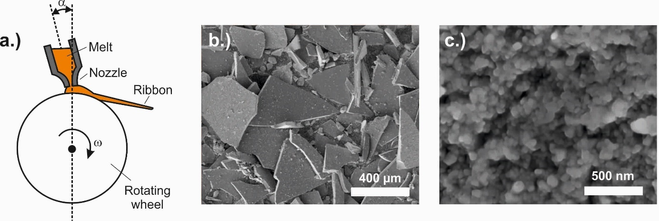
Figure 1: Nanocrystalline Nd-Fe-B powder (commercial MQU-F powder from the company Magnequench) made by melt-spinning a.) Principle of melt-spinning b.) Macroscopic powder flakes c.) Nanocrystalline Nd₂Fe₁₄B grains. The different size of the scale bars is pointed out.

Nanocrystalline Nd-Fe-B powders can be directly used in polymer bonded magnets, resulting in a good compromise of isotropic magnetic properties and costs. As an alternative, nanocrystalline Nd-Fe-B powders can be used as starting material for the manufacturing of high-performing fully dense anisotropic magnets by applying a multiple-stage production process [Hioki 2021, Khlopkov 2007, Song 2013, Croat 2018]. As a first step, the powder is cold pressed. Then, the compacts are fully densified by hot pressing at temperatures in the range of 650°C – 900°C and a pressure of up to 300 MPa [Song 2013, Croat 2018]. In the as hot-pressed state, the semi-finished parts contain randomly aligned grains with a size in the range of 20 – 50 nm. Due to the random orientation of the grains, isotropic magnetic properties are obtained at this stage. As last step, anisotropic magnetic properties are achieved by hot deformation of the semi-finished parts either by die-upsetting (plane magnets) or hot extrusion (ring magnets) [Grünberger 1997]. A deformation degree (= height reduction in relation to the initial height) of up to 70 % can be achieved by applying temperatures in the range of 650°C – 900°C and a pressure of up to 100 MPa [Hioki 2021, Song 2013, Croat 2018]. The magnetic properties of the Nd-Fe-B magnets are influenced by this deformation degree. As the deformation degree increases, the fiber texture also increases, indicating a higher alignment of the “c” crystallographic/easy magnetization axis of the Nd-Fe-B grains along the pressure direction. This alignment leads to an increase in remanence and, consequently, energy-product [Khlopkov 2004]. On the nano-scale, anisotropic grain growth occurs resulting – in the ideal case – in plate-like grains with a width in the range of 200 – 500 nm and a height of 20 – 50 nm. Nevertheless, there is no consensus in the literature on the reason behind this phenomenon. Different mechanisms were proposed, including the combination of anisotropic grain growth followed by “rotation and grain boundary sliding” [Hioki 2021], “grain boundary migration” [Mishra 1990], “solution-precipitation creep” [Grünberger 1997] and “anisotropic elastic properties” [Simon 2019]. Figure 2 illustrates the microstructure evolution of nanocrystalline Nd-Fe-B magnets adapted for the specific case of field assisted sintering technologies. For a more detailed description, we refer to the excellent review paper of Hioki [Hioki 2021].

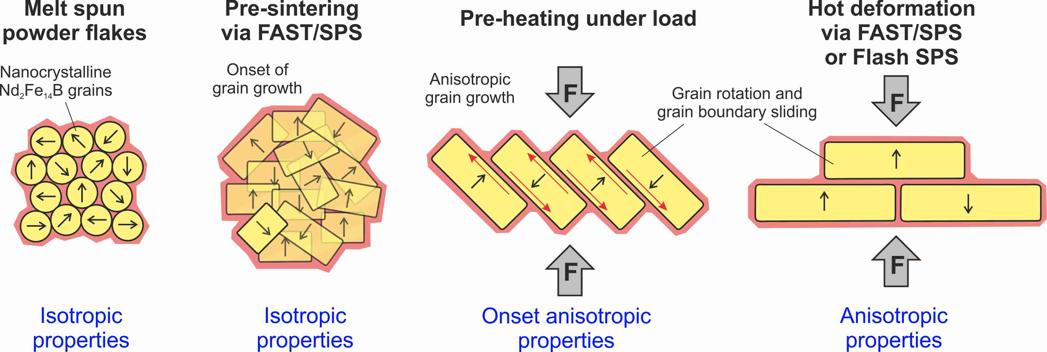
Figure 2: Anisotropic grain growth during Flash SPS and alignment of the nanocrystalline grains perpendicular to the pressing direction leads to anisotropic magnetic properties of nanocrystalline Nd-Fe-B magnets. Adapted from Hioki [Hioki 2021] for the specific case of field assisted sintering of Nd-Fe-B magnets.

Electric current assisted sintering (ECAS) technologies are an attractive alternative for hot deformation of nanocrystalline Nd-Fe-B magnets. It is expected that direct Joule heating of the compacts by current flow through the bulk in combination with a moderate load further improves microstructure evolution. Our research hypothesis is that electroplasticity occurs as additional deformation and densification mechanism [Ruszkiewicz 2017], leading to an improved deformation behaviour and a reduced tool wear [Dimitrov 2022]. Furthermore, electroplasticity might enable a new degree of freedom to adjust the microstructure which is not possible with established manufacturing routes. In ideal case, this helps to achieve the best compromise regarding high coercivity and high remanence and to reduce the amount of heavy rare earth elements (HREEs) in Nd-Fe-B magnets without loss of magnetic performance [Castle 2017]. Furthermore, it has been demonstrated recently that there is a potential of ECAS technologies for the direct recycling of magnet scrap, which is not accessible by the technologies mentioned above [Leich 2019, Mishra 2023, Keszler 2023].

Several ECAS technologies have been investigated for the processing of Nd-Fe-B magnets so far. In all cases, melt-spun, nanocrystalline Nd-Fe-B powders or scrap from hot-deformed magnets has been used as starting materials.

1) Electro discharge sintering (EDS): Leich et al. reported the production of Nd-Fe-B Magnets with isotropic magnetic properties by EDS [Leich 2019, Leich 2018]. Due to densification in milliseconds by sudden release of energy stored in a capacitor, this method is the most economical of all sintering technologies, but achieving high microstructural homogeneity is challenging and there is a limitation of the maximum sample size. At current status of the development, the projected area is below 350 mm² [Fais 2020].

2) Field assisted sintering technology/spark plasma sintering (FAST/SPS): Several authors investigated field assisted sintering technology/spark plasma sintering (FAST/SPS) as promising alternative to hot pressing demonstrating almost full densification of Nd-Fe-B magnets [Gopalan 2009, Liu 2010, Hu 2011, Liu 2012, Wüst 2015, Wang 2015, Tomše 2020, Tomše 2021]. In FAST/SPS, the powder is placed in a conductive tool consisting of two punches and a die. After mounting in the FAST/SPS device, the tool is loaded by a hydraulic system and heated by direct current flow (= Joule heating). Depending on the kind of FAST/SPS device, pulsed current or constant current is used. For conductive powder – as is the case for Nd-Fe-B powders – indirect heating by thermal conduction is superimposed by direct Joule heating of the powder. In literature, FAST/SPS of Nd-Fe-B powders was usually done at temperatures in the range of 600 – 900°C. For shifting the temperature to the lower bound, pressures up to 500 MPa were applied by using WC tools. Wang et al. reported that the magnetic properties improved when the current-pulse-ratio (CPR) for operating the FAST/SPS device was changed from 12:2 to 2:2 indicating the influence of current flow on the resulting magnetic properties [Wang 2015]. Due to the lack of texture development in the case of single-stage FAST/SPS, magnets with isotropic properties resulted in this case. To overcome this restriction, several attempts were reported in literature where the authors conducted die-upsetting in a FAST/SPS device as second processing stage, resulting in Nd-Fe-B magnets with anisotropic properties. Unfortunately, information about exact tool design, complete set of deformation parameters, dimensional accuracy and microstructural homogeneity is rare [Gopalan 2009, Liu 2010, Hu 2011, Liu 2012, Huang 2012, Wang 2015, Tomše 2020].

3) Flash Spark Plasma Sintering (Flash SPS): Flash SPS is a novel method which combines the advantages of EDS and FAST/SPS. Originally developed by Grasso et al. for the densification of ceramic materials [Grasso 2014], Flash SPS was adapted by Castle et al. for the production of Nd-Fe-B magnets recently demonstrating well-pronounced anisotropic magnetic properties [Castle 2017]. Flash SPS cycles can be conducted in a conventional FAST/SPS device. A high-power pulse of several 10 kW and a defined length (usually less than 60 s) is forced through a pre-compacted/pre-sintered sample resulting in simultaneous densification and hot deformation with large height reduction. Our recent works show that comprehensive data analysis possible in a FAST/SPS device enabled to exactly tune the crystallographic texture while keeping the grain size on the nanoscale [Mishra 2023, Maccari 2023]. Both properties are prerequisite to achieve pronounced anisotropic magnetic properties. Figure 3 schematically shows the experimental setup and the different processing steps of hot deformation via the Flash SPS process.

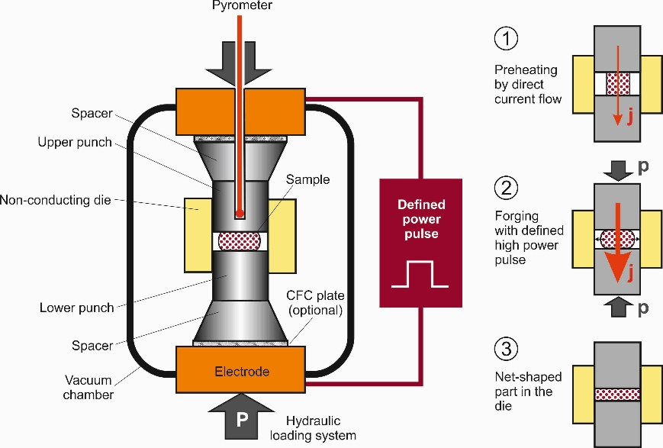
Figure 3: Principle of Flash Spark Plasma Sintering (Flash SPS) in a conventional FAST/SPS device.

The aim of the present work is to summarize the state-of-the-art and – based on this – gain a better understanding of the requirements for manufacturing Nd-Fe-B magnets with well-pronounced anisotropic properties by field assisted sintering technologies. For a more detailed description of the specific kind of deformation processes taking place when applying these technologies, systematic experimental series were done, either doing the hot deformation step in the FAST/SPS mode or in the Flash SPS mode. In the case of FAST/SPS, sample is pre-heated with a defined heating-rate to the aspired temperature and then the load is applied. In the case of Flash SPS, sample is pre-heated under load. After achieving the aspired pre-heating temperature, a dwell time of 2 min followed and then a defined power pulse was applied for a given time. Detailed description of the experimental setup in combination with careful data and microstructure analysis are the keys for reliable benchmarking field assisted sintering technologies with respect to established hot deformation technologies. Due to focusing on the benchmarking of field assisted sintering technologies, only a comprehensive summary of our experimental results will be presented in this work. For more details, we refer to our recent publications [Mishra 2023, Maccari 2023, Keszler 2023].

2. Experimental
2.1 Starting materials and pre-sintering of compacts
As starting material, commercial melt-spun Nd-Fe-B powder (MQU-F, Magnequench, China) was used (see Figure 1). The coarse flakes had a size of up to 400 µm with a maximum in the range of 150 – 250 µm. The tapping density of the coarse flakes was around 46 %, making it challenging to fill a pressing tool evenly. The coarse flakes contain nanocrystalline grains with a size below 50 nm. The MQU-F powder had a nominal composition of 30.0% Nd, 5.88% Co, 0.60% Ga, 0.92% B (all values in wt. %) and Fe as balance. Due to the suboptimal compaction behaviour of the pure flakes, the powder had to be pre-sintered by conventional FAST/SPS to withstand the minimum load of 10 kN (= 32 MPa for a ∅ 20 mm sample) required for operating the FAST/SPS devices used in this study. Two strategies were pursued for pre-sintering.

At Forschungszentrum Jülich, pre-sintering was done in our lab-scale FAST/SPS device (HP-D 5, FCT Systeme GmbH, Germany). Starting powder (15 g) was poured into a FAST/SPS graphite die (graphite type R7710, SGL Carbon GmbH, Germany) which had an internal diameter of 20 mm. Graphite foil with a thickness of 0.38 mm (SGL Carbon, SIGRAFEX) was used to line the die and punches in each process. FAST/SPS cycles were done with a heating rate of 100 K/min, a temperature of 500°C, a dwell time of 30 s and a pressure of 50 MPa resulting in pre-sintered pellets with a height around 8 mm and a relative density in the range of 70 – 75 % [Mishra 2023]. Figure 4 shows the microstructure of a pre-sintered sample, where the powder flakes of the starting powder are still clearly visible. Inhomogeneous tilting of the former powder flakes explains the large scattering of residual porosity of the pre-sintered compacts. Due to low pre-sintering temperature, growth of the primary grains (see Figure 1c) and formation of transient liquid phase was avoided reliably [Maccari 2023]. Same kind of pre-sintered compacts was used for all subsequent FAST/SPS and Flash SPS trials done at Forschungszentrum Jülich.

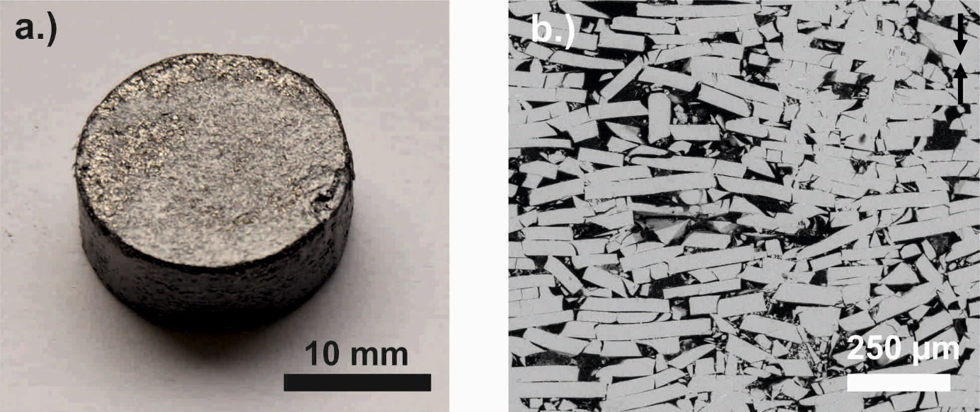
Figure 4. a.) Optical appearance of a Nd-Fe-B sample pre-sintered by FAST/SPS from melt-spun MQU-F powder (100 K⋅min⁻¹, 50 MPa, 500°C, 30 s) b.) Related microstructure. For higher magnification, we refer to our former work [Maccari 2023].

At Fraunhofer IWKS, pre-sintering was done in the FAST/SPS device HP-D10 (FCT Systeme GmbH, Germany), using a standard FAST/SPS graphite die (graphite type R7710, SGL Carbon GmbH, Germany) with inner diameter of 10 mm and graphite foil with a thickness of 0.35 mm (SGL Carbon, SIGRAFEX). The mould was filled with 5 g of MQU-F powder resulting in a 16 mm high close packed powder column (calculated tap density ca. 51 %).
Based on the experimental results obtained during the hot deformation (described in detail later in this article) it was found out that residual porosity of the pre-sintered samples has negative impact on the microstructure and therefore should be avoided. Due to the limitation of the graphite tool set on the maximum applied pressure, the compaction temperature was gradually increased, while keeping the pressure at 50 MPa, aiming to obtain fully dense samples without significant grain growth. On Fig. 5, the microstructure of the samples compacted at 700°C, 725°C and 750°C are presented. As shown on Fig. 5 (a) at 700°C the sample has ca. 90% density, melt spun flakes are mostly aligned and no grain growth is observed. The sample compacted at 725°C (Fig. 5 (b)) is fully dense with the melt spun flakes well aligned in whole sample volume and pronounced grain growth is not observed. The sample compacted at 750°C (Fig. 5 (c)) is also fully dense, but abnormal grain growth can be seen on the melt spun flakes boundaries. Based on these results, the compaction temperature was set to be 725°C. The optimal parameters for the FAST/SPS cycles were selected as follow: The contact pressure of 38 MPa was applied while the sample was heated up to 725°C with heating rate of 75 K/min. During the dwell time of 60 s the pressure was increased from 38 to 45 MPa. After processing the height of the pre-sintered pellets was found to be ca. 8 mm, which corresponds to a density of 100 %, as determined by the Archimedes’ method (Sartorius Quintix224-1CEU balance with YDK03 option).

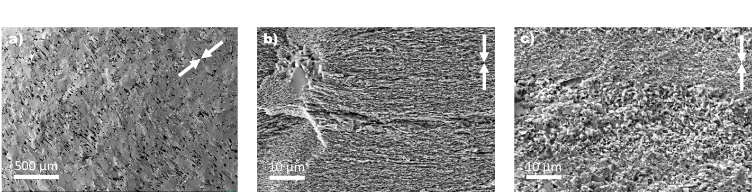
Figure 5: Optical appearance of a Nd-Fe-B sample pre-sintered by FAST/SPS from melt-spun MQU-F powder processed with heating rate of 75 K⋅min⁻¹ and pressure of 45 MPa during the dwelling time of 60 s at: a.) 700°C sample has 90% of the theoretical density, porosity is visible, some ribbons are not aligned; b.) 725°C sample has 99% of the theoretical density, all ribbons are aligned, no significant grain growth; c.) 750°C sample has 99% of the theoretical density, all ribbons are aligned, but significant grain growth is observed. Note the difference in scale bar between a) and the other two micrographs.

2.2 Hot deformation via FAST/SPS
For hot deformation in FAST/SPS mode, two different approaches were considered.

The main idea of our first attempt done at Forschungszentrum Jülich was to start from a pre-sintered compact where the pristine microstructure is maintained to a large extent. Then, anisotropic grain growth is initiated by rapid heating to deformation temperature under the pre-load required for operating the FAST/SPS device (10 kN) and then applying high loads up to 500 MPa followed by a short dwell time of 10 s. For conducting this kind of experiments, ∅ 20 mm samples pre-sintered at 500°C were placed in a ∅ 30 mm FAST/SPS tool, which was lined with a 0.38 mm thick graphite foil (SGL Carbon, SIGRAFEX). For the pressure of 50 MPa, the tool was made of graphite (graphite type R7710, SGL Carbon GmbH, Germany). For pressures > 50 MPa, a ∅ 30 mm tool made of the Mo-based alloy TZM (Plansee, Reutte, Austria) was used. The respective tool with the sample was mounted in the hybrid FAST/SPS device (H-HP-D25 SD/FL/MoSi, FCT Systeme GmbH, Germany) and the pre-load of 10 kN (= 32 MPa for a ∅ 20 mm sample) was applied. Then the sample was heated with a defined heating rate to the aspired deformation temperature. When achieving the temperature, the load was increased with a rate of approximately 100 MPa⋅min⁻¹ to the aspired value. Then, after a constant holding time of 10 s, the sample was furnace cooled. Hot deformation of pre-sintered samples via FAST/SPS was carried out at different temperatures, heating rates and pressures. In all cases, sample diameter after deformation reached 30 mm, so wall friction due to the contact with the die might have influenced the height reduction in the final stage of deformation Table 1 summarizes the various parameter sets. In the T-series (T700-50, T750-50, T800-50), the temperature was varied to 700, 750 and 800°C, while the pressure of 50 MPa was kept constant. In the P-series, the pressure was varied to 100, 200 and 500 MPa at a constant temperature of 800°C. For the current pulse ratio (CPR), we used the standard configuration of our FAST/SPS 12:2.

Table 1. FAST/SPS parameters used for hot deformation of porous Nd-Fe-B samples (pre-sintering 500°C, 50 MPa, 10 min). Deformation and densification in relation to change of pressure, temperature, and heating rate.
Sample code | Heating rate [K/min] | Max. tempera-ture  [°C] | Pressure  [MPa] | Hold time  [s] | Height Reduction  [%] | Relative Density  [%]
T700-50 | 100 | 700 | 50 | 10 | 57.1 | 97
T750-50 | 100 | 750 | 50 | 10 | 59.3 | 97
T800-50 | 100 | 800 | 50 | 10 | 62 | 97
P800-100 | 100 | 800 | 100 | 10 | 60 | 98
P800-200 | 100 | 800 | 200 | 10 | 61 | 96
P800-500 | 100 | 800 | 500 | 10 | 65 | 99

The second attempt done at Fraunhofer IWKS is based on the conventional hot deformation of anisotropic Nd-Fe-B magnets by using SPS technique. Therefore, samples were hot compacted firstly by FAST/SPS to nearly theoretical density, based on the optimized parameters as described previously – 725°C and 45 MPa pressure (See Fig. HotDef a.)) For hot deformation in the FAST/SPS device, the ∅ 10 mm samples were placed in a ∅ 20 mm graphite tool (SGL Carbon, SIGRAFINE R7710). Prior to hot deformation, the hot compacted samples were sandblasted and sharp edges were removed to avoid damaging of the graphite pressing tools (see Fig. HotDef b)).
Hot deformation was carried out in the FAST/SPS device HP-D10 (FCT Systeme GmbH, Germany). A graphite foil (SGL Carbon, SIGRAFEX) with a thickness of 0.35 mm with additional centring ring made of the same graphite foil was used to ensure the centralized placement of the specimen and to guarantee homogeneous deformation.
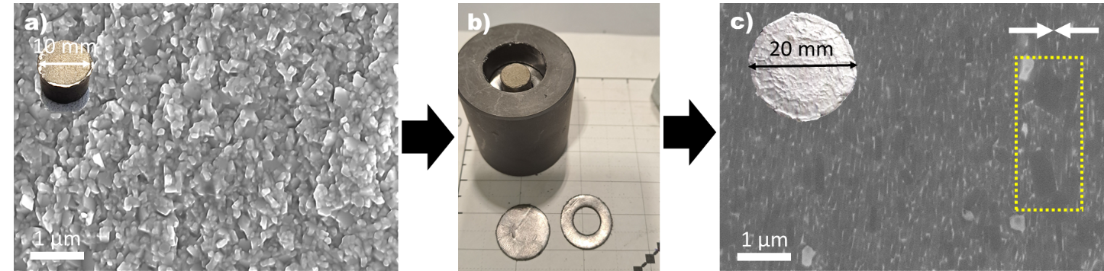
Fig. HotDef : Schematic of the hot deformation process starting with a) 10 mm dense hot compacted pellet with isotropic nanograin microstructure; centring the pellet in 20 mm graphite die; c) 20 mm hot deformed sample with anisotropic nanograin microstructure (grain grow can be observed in the area outlined by yellow dotted line) .

The processing parameters for the deformation were optimized aiming to obtain fibre texture while avoiding abnormal/excessive grain growth. Based on literature data (ref. Diss Simon), the deformation temperature was set to be 750°C (25°C above the compaction temperature). The pre -load of 10 MPa (minimum required for the device) was applied during the sample was heated up to 600°C with 75 C/min. During the next step the sample was heated up to 750°C with 75 C/min and pressure was increased to 50 MPa. The pressure was further kept at 50 MPa during the dwell time of 60 s at 750°C followed by cooling, in which the power was switched off (see Table 1).
The sample (HDS501) obtained with those deformation parameters, had final diameter of 19 mm, meaning that the deformation was not fully completed considering the 20 mm diameter of the graphite die used in the process. Therefore, the sample was not well formed at the edge, where cracks were visible. Consequently, the degree of alignment was inhomogeneous at the outer part while homogeneous in the centre.
To complete the deformation and improve the microstructure (texture) the pressure during the dwell time of 60 s at 750°C was further increased to 60 MPa (HDS60x), 70 MPa (HDS70x) and 80 MPa (HDS80x), being kept constant during the sample colling.
By increasing the applied pressure, a significant improvement on the alignment was obtained, however grain growth was observed, probably due to better heat exchange?. Further deformation experiments were done by varying the heating rate (50 to 100 °C/min) and the dwelling temperature (see Table 2). Based on the observed microstructure, the best results are obtained with heating rate of 75 °C/min and pressure of 70 MPa during dwell time of 60 s at 750°C, since it resulted in a microstructure with well aligned grains with fine microstructure (see Fig HotDef c)).

Table 2. FAST/SPS parameters used for hot deformation of almost dense Nd-Fe-B samples (750°C, 70 MPa, 1 min). Deformation and densification in relation to change of pressure, temperature, and heating rate.
Sample code | Heating rate [K/min] | Max. temperature  [°C] | Pressure  [MPa] | Hold time  [s] | Height Reduction  [%] | Relative Density  [%]
HDS 501 | 75 | 750 | 50 | 60 | 70 | 100
HDS 601 | 75 | 750 | 60 | 60 | 73 | 100
HDS 701 | 75 | 750 | 70 | 60 | 75 | 100
HDS 702 | 100 | 750 | 70 | 60 | 75 | 100
HDS 703 | 50 | 750 | 70 | 60 | 75 | 100
HDS 704 | 75 | 750 | 70 | 30 | 55 | 100
HDS 801 | 75 | 750 | 80 | 60 | 75 | 100
HDS 802 | 75 | 725 | 80 | 60 | 75 | 100

2.3. Hot deformation via Flash SPS
All Flash SPS cycles were conducted at Forschungszentrum Jülich. Therefore, the samples pre-sintered by FAST/SPS at 500°C were placed in the hybrid FAST/SPS device H-HP-D25 SD/FL/MoSi (FCT Systeme GmbH, Germany) between two ∅ 60 mm graphite punches. At current state of development, the non-conducting die (see sketch Figure 3) was still omitted. Before starting the Flash SPS cycle, the samples were pre-loaded with 10 kN (32 MPa for a ∅ 20 mm sample) again. Before applying the Flash SPS power pulse, the samples were pre-heated to 251°C, 300°C, 400°C, 500°C and 600°C by direct current flow (Joule heating) through the pre-sintered compacts. Pre-heating was done below the melting temperature of a Nd-rich liquid phase, which is reported in literature to appear above 655°C [Grieb 1992]. Formation of a liquid phase already in the pre-heating stage is expected to cause an anomalous grain growth of the nanocrystals already at this processing stage and should be therefore avoided. In our experiments, the pre-heating temperature was controlled by a pyrometer, which was focused on the bottom of a drilling in the upper punch. The measuring range of the pyrometer used in this study limited the lower pre-heating temperature to 251°C. After achieving the pre-heating temperature, the respective temperature was held for 120 s. Then, a constant power pulse of 35 kW was applied for all samples. The power was kept for 30 s and then switched off enabling sample cooling in less than 200 s. The optimum value for the power pulse and the dwell time were investigated in a recent study [Mishra 2023]. Table 3 summarizes all Flash SPS parameters used in this study. For a more detailed description, see the recent work of Maccari et al. [Maccari 2023]. Due to omitting the outer die in these experimental series, the samples had a frayed edge and limited dimensional accuracy as exemplarily shown in Figure 6. To exclude the influence of the less defined outer edge on magnetic properties, a 20 mm cylinder was cut from the centre of the samples by electro discharge machining for further characterization.

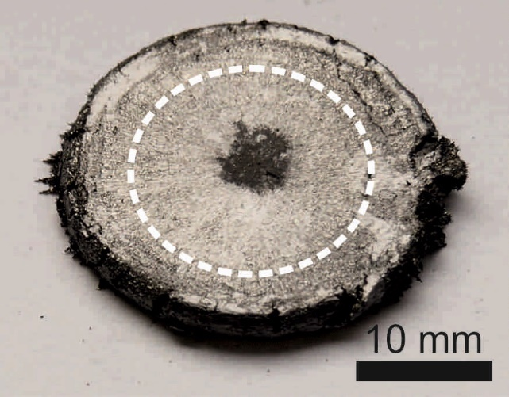
Figure 6: Appearance of a Nd-Fe-B sample after Flash SPS deformation without an outer die. For analysis of relative density and magnetic properties, a ∅ 20 mm cylinder was cut from the centre (see dotted line).

Table 3. Parameters used for hot deformation via Flash SPS for studying the influence of the pre-heating temperature on height reduction, microstructure evolution and magnetic properties. The relative density refers to the inner part of the sample.
Sample code | Pre-heating  temperature  [°C] | Flash SPS power pulse  [kW] | Dwell time  [s] | Pressure  [MPa] | Height Reduction  [%] | Relative Density  [%]
F35_251 | 251 | 35 | 30 | 32 | 51.0 | 96
F35_300 | 300 | 35 | 30 | 32 | 63.9 | 97
F35_400 | 400 | 35 | 30 | 32 | 67.6 | 98
F35_500 | 500 | 35 | 30 | 32 | 68.6 | 97
F35_600 | 600 | 35 | 30 | 32 | 71.1 | 98

2.4. Characterization methods
The relative density was calculated based on the Archimedes principle. For the calculation, a theoretical density of 7.55 g⋅cm⁻³ was used. Scanning electron microscopy (SEM) with a FEG-SEM JEOL JSM-7600 device (JEOL, Japan) was used to characterize the microstructure depending on the processing conditions. Before microstructure characterization, all samples were broken into two halves. For investigation of microstructure on larger scale, one half was embedded in epoxy resin, ground with silicon carbide emery paper and then polished with water-free diamond suspensions down to 0.25 µm. The fractured surface of the other half was used for characterization of the primary nanocrystalline grains. For characterization of the magnetic properties of FAST/SPS samples, a Permagraph C-300 system (MAGNET-PHYSIK Dr. Steingroever GmbH, Köln, Germany) was used. For characterization of the magnetic properties of the Flash SPS samples, cuboid shaped samples with a size of 1.30 x 1.30 x 3.30 mm³ (larger dimension parallel to the pressure direction) were cut near to the centre of the sample. A vibrating magnetometer module in a magnetic property measurement system (VSM-MPMS3, Quantum Design, USA) was used to measure the magnetic hysteresis loops characterizing the respective magnetization and demagnetization behaviour of the samples.

3. Results
Table 4 summarizes the magnetic properties coercivity H_{cJ}, remanence B_{r} and energy-product (BH)_{max} of Nd-Fe-B magnets processed by the different field assisted sintering technologies. For benchmark, results from our former study [Mishra 2023] and related results from literature were included. In the latter case, it must be considered that not always MQU-F powder was used as starting material. Nevertheless, trends how field assisted sintering parameters influence final microstructure and magnetic properties are obvious enabling reliable conclusions how to further optimize these technologies in future. As reference, magnetic properties of a MQU-F based die-upsetted magnets from a commercial water pump from the company WILO are considered as well. For exceeding the current industrial standard of anisotropic Nd-Fe-B magnets made by WILO, magnets should combine a coercivity higher than 1300 kA⋅m⁻¹ and a remanence higher than 1.3 T. For practical application, a high coercivity means that the permanent magnet is stable against demagnetization, e.g., when placing it in a magnetic field with opposite polarisation. A high remanence means that the magnet has a high permanent magnetization when the external magnetic field is turned to zero. In short, the magnet exerts a strong magnetic force without any external magnetic field. The stronger the magnetic force, the smaller the magnets can be designed, which is advantageous e.g., for high-performing electromotors with space limitations. For better interpretation of the results, some general relationships between microstructural features and magnetic properties are shortly summarized here [Croat 2018]. The coercivity is directly coupled with the size of the nanocrystalline grains. The highest coercivity is usually achieved in the as melt-spun starting powder. For MQU-F powder, a coercivity of 1693 kA⋅m⁻¹ was measured. Onset of grain growth during magnet production is indicated by a decrease of the coercivity. The remanence is directly coupled with the amount of the main magnetic phase Nd₂Fe₁₄B in the sample volume. Non-magnetic secondary phases or residual pores lead to a decrease of the remanence. Furthermore, the remanence value is a measure for the anisotropy of the magnet. The maximum remanence of a fully isotropic Nd-Fe-B magnet is 0.8 T. Values above 0.8 indicate the onset of anisotropic grain growth and texture formation. High anisotropy is another tuning factor when aiming on compact magnet design. Last not least, the maximum energy product (BH)_{max} is the most important figure-of-merit for characterizing the general strength of a permanent magnet material. There are further microstructural features which influence the magnetic properties, but they are out of the scope and therefore not discussed in the present work.

Table 4: Height reduction, coercivity H_{cJ}, remanence B_{r} and energy product (BH)_{max} of Nd-Fe-B magnets processed by different field assisted sintering technologies starting from MQU-F powder in all cases. Results of this work are benchmarked with related results from literature. As reference, properties of MQU-F powder and a commercial magnet from WILO, Germany are shown (n.a. = not available).
Reference | Manufacturing route | Starting powder | Height reduction [%] | H_{cJ}  [kA⋅m⁻¹] | B_{r}  [T] | (BH)_{max}  [kJ⋅m⁻³]
Commercial powder (Magnequench) | Melt-spinning | MQU-F | - | 1693 | 0.74 | 91
Commercial magnet  (WILO) | Hot pressing | MQU-F | n.a. | 1569 | 0.83 | 120
Commercial magnet  (WILO) | Hot pressing + die upsetting | MQU-F | n.a. | 1342 | 1.30 | 323
Leich et al.  [Leich 2018] | Electro discharge sintering (EDS) | MQU-F | n.a. | 1565 | 0.78 | 102
Liu et al.  [Liu 2010] | FAST/SPS  (630°C, 400 MPa, 3 min) | MQP-UG | n.a. | 1614 | 0.73 | 98
Liu et al.  [Liu 2010] | FAST/SPS +  Hot deformation via FAST/SPS  (700°C, 400 MPa) | MQP-UG | 80 | 1004 | 1.49 | 400
Wang et al.  [Wang 2015] | FAST/SPS  (650°C, 500 MPa, 3s) | MQP-F | n.a. | 1607 | 0.84 | 121
Wang et al.  [Wang 2015] | FAST/SPS +  Hot deformation via FAST/SPS  (750°C, 500 MPa) | MQP-F | 70 | 1228 | 1.14 | 384
Mishra et al.  [Mishra 2023] | FAST/SPS  (500°C, 50 MPa, 30 s) | MQU-F | n.a. | 1668 | 0.62 | 68
Mishra et al.  [Mishra 2023] | FAST/SPS  (800°C, 50 MPa, 30 s) | MQU-F | n.a. | 1269 | 0.85 | 122
This work  IWKS | FAST/SPS  (725°C, 45 MPa, 60 s)C | MQU-F | 50 | 1648 | 0.83 | 123
Castle et al.  [Castle 2017] | Flash SPS  Pre-heating 450°C | MQU-F | n.a. | 1438 | 1.16 | 230
This work  T700-50 | FAST/SPS +  Hot deformation via FAST/SPS  (700°C, 50 MPa, 10s) | MQU-F | 57 | ~1250 | ~1.05 | ~200
This work  T750-50 | FAST/SPS +  Hot deformation via FAST/SPS  (750°C, 50 MPa, 10s) | MQU-F | 59 | ~1080 | ~1.04 | ~190
This work  T800-50 | FAST/SPS +  Hot deformation via FAST/SPS  (800°C, 50 MPa, 10s) | MQU-F | 62 | ~1100 | ~ 1.11 | ~215
This work  P800-100 | FAST/SPS +  Hot deformation via FAST/SPS  (800°C, 100 MPa, 10s) | MQU-F | 60 | ~1200 | ~ 1.18 | ~250
This work  P800-200 | FAST/SPS +  Hot deformation via FAST/SPS  (800°C, 200 MPa, 10s) | MQU-F | 61 | ~ 800 | ~ 1.05 | ~180
This work  P800-500 | FAST/SPS +  Hot deformation via FAST/SPS  (800°C, 500 MPa, 10s) | MQU-F | 65 | ~ 800 | ~ 1.25 | ~ 275
This work  IWKS | FAST/SPS +  Hot deformation via FAST/SPS  (750°C, 70 MPa, 60s) | MQU-F | 75 | 1180 | 1.38 | 305
This work  IWKS | FAST/SPS +  Hot deformation via FAST/SPS  (750°C, 70 MPa, 60s) | MQU-F | 50 | 1438 | 1.22 | 325
This work  F35_251 | FAST/SPS + Flash SPS  Pre-heating 251°C | MQU-F | 51 | 1412 | 0.98 | 169
This work  F35_300 | FAST/SPS + Flash SPS  Pre-heating 300°C | MQU-F | 64 | 1353 | 1.07 | 209
This work  F35_400 | FAST/SPS + Flash SPS  Pre-heating 400°C | MQU-F | 68 | 1305 | 1.27 | 295
This work  F35_500 | FAST/SPS + Flash SPS  Pre-heating 500°C | MQU-F | 69 | 1215 | 1.32 | 324
This work  F35_600 | FAST/SPS + Flash SPS  Pre-heating 600°C | MQU-F | 71 | 927 | 1.39 | 364

In the literature, exact information and discussion on how the processing parameters of hot deformation in a FAST/SPS influences the properties of anisotropic Nd-Fe-B magnets are rare. Our systematic experimental approach enables to draw more reliable conclusions on the key parameters for exactly tuning the magnetic properties when using field assisted sintering technologies for the production of anisotropic Nd-Fe-B magnets.

3.1 Hot deformation of pre-sintered, porous compacts by FAST/SPS
All samples were pre-sintered via FAST/SPS at low temperature (500°C, 50 MPa, 30 s), so the growth of the nano crystalline grains can be almost neglected. This is confirmed by similar magnetic properties of MQU-F starting powder and pre-sintered samples (see Table 4). For initiating anisotropic grain growth, the pre-sintered samples were placed in the FAST/SPS, pre-loaded with 32 MPa and then heated with 100°C⋅min⁻¹ to the aspired temperature (700°C, 750°C, 800°C). Then, a higher load in the range of 50 – 500 MPa (related to the diameter of the pre-sintered compact) was applied to terminate the deformation. After reaching this load followed by a short dwell time of 10 s, the current was turned off.

As expected, densification improved with increase of temperature and increase of pressure (see Table 4). The lowest height reduction of 57 % occurred at 700°C and 50 MPa. Since higher deformation degrees were obtained at 800 °C compared to 700 °C and 750 °C, further deformation studies with varying pressure (100, 200, 500 MPa) were carried out at this temperature. Figure 7 shows the related deformation curves for the case of doing the main deformation step with a pressure of either 100 MPa (Figure 7a) or 500 MPa (Figure 7b). With increase of pressure, the height reduction increased from 60 to 65 % (Table 4). The black line in the graphs show the relative movement of the punch along with the deformation process. It must be considered that the displacement curve is affected by the thermal expansion of punches and densification of samples. Nevertheless, the main trends are obvious. Not unexpected, deformation starts already under the pre-load at a temperature of around 500°C. When exceeding a temperature of around 650°C deformation stops at a height reduction of around xx %. The plateau of the deformation curve indicates that the samples were deformed to a degree, where contact to die walls and onset of wall friction appeared. When further increasing the load, deformation proceeds, but at a lower rate. Even in the cooling phase, where the load was released linearly, deformation still continues.

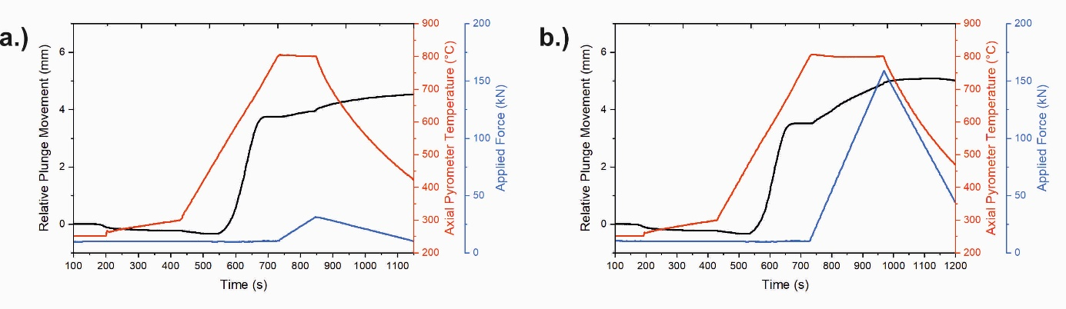
Figure 7: Hot deformation of pre-sintered, porous Nd-Fe-B samples (500°C, 50 MPa, 30s) via FAST/SPS. Pre-heating with 100°C⋅min⁻¹ to 800°C and pre-loading with 32 MPa before applying the main pressure of a.) 100 MPa b.) 500 MPa (Pressure related to the initial sample diameter of 20 mm).

In this experimental approach, the highest remanence value (1.25T) was obtained from the experiment with the maximum applied pressure of 500 MPa. In addition, the highest density and the largest height reduction were obtained as well. This result indicates that hot deformation at high pressure is advantageous for texturing the grains, therefore achieving pronounced anisotropic magnetic properties. Similar trends were observed in the literature [Liu 2010, Wang 2015]. Nevertheless, heating with 100°C⋅min⁻¹ to the aspired deformation temperature followed by another dwell time at this temperature until the main deformation load is achieved took obviously too long to reliable avoid onset of anomalous grain growth. This assumption is confirmed when having a look on the related microstructures (Figure 8). Large amounts of grains with sizes in the several micrometer range are a clear indicator for explaining the low coercivity values. For taking advantage of high pressure and on the same time avoiding anomalous grain growth, direct application of the high load seems to be the preferred option, but sufficient stability of our pre-sintered, porous compacts is questionable in this case.

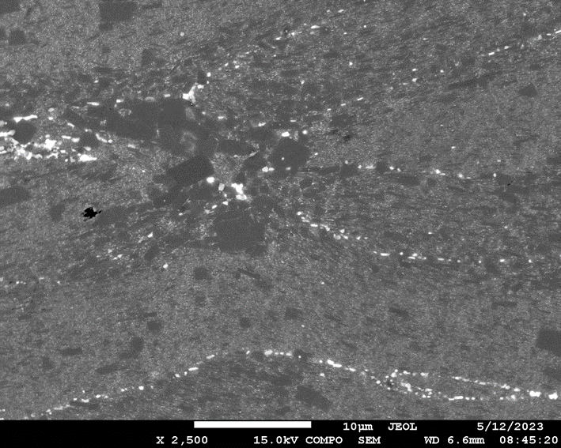 | 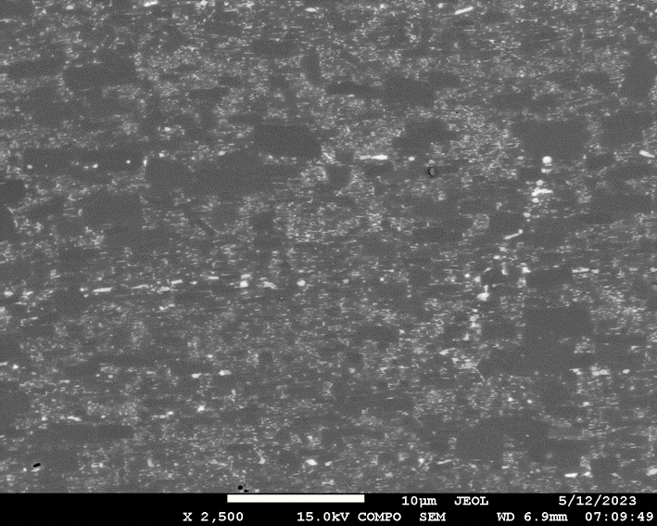
Figure 8. Samples deformed at different maximum pressures. The sample deformed at 100 MPa (left) displays significantly less alignment than the sample deformed at 500 MPa (right). The 500 MPa sample also displays much larger grains.

3.2 Hot deformation of pre-sintered, dense compacts by FAST/SPS
For increasing the stability of the pre-sintered compacts and for improving the ability to produce net-shaped magnets with homogeneous microstructure, in this experimental series all samples were pre-sintered by FAST/SPS to almost theoretical density. This approach is in accordance with established magnet production by hot pressing and die-upsetting [Croat 2018].
Figure 9 shows the typical FAST/SPS cycles used for production of hot compacted (Fig. 9 a) and hot deformed (Fig. 9 b) Nd-Fe-B samples. For the hot deformation contact pressure of 10 MPa (calculated for the 20 mm die) was applied and temperature was increased up to 750 °C with heating rate of 75°C/min. Once the sample temperature reached 600°C, pressure and temperature were increased simultaneously till reached 50 MPa at 750°C. The pressure was further increased during the 60 seconds dwelling step at 750°C (See Fig 9).

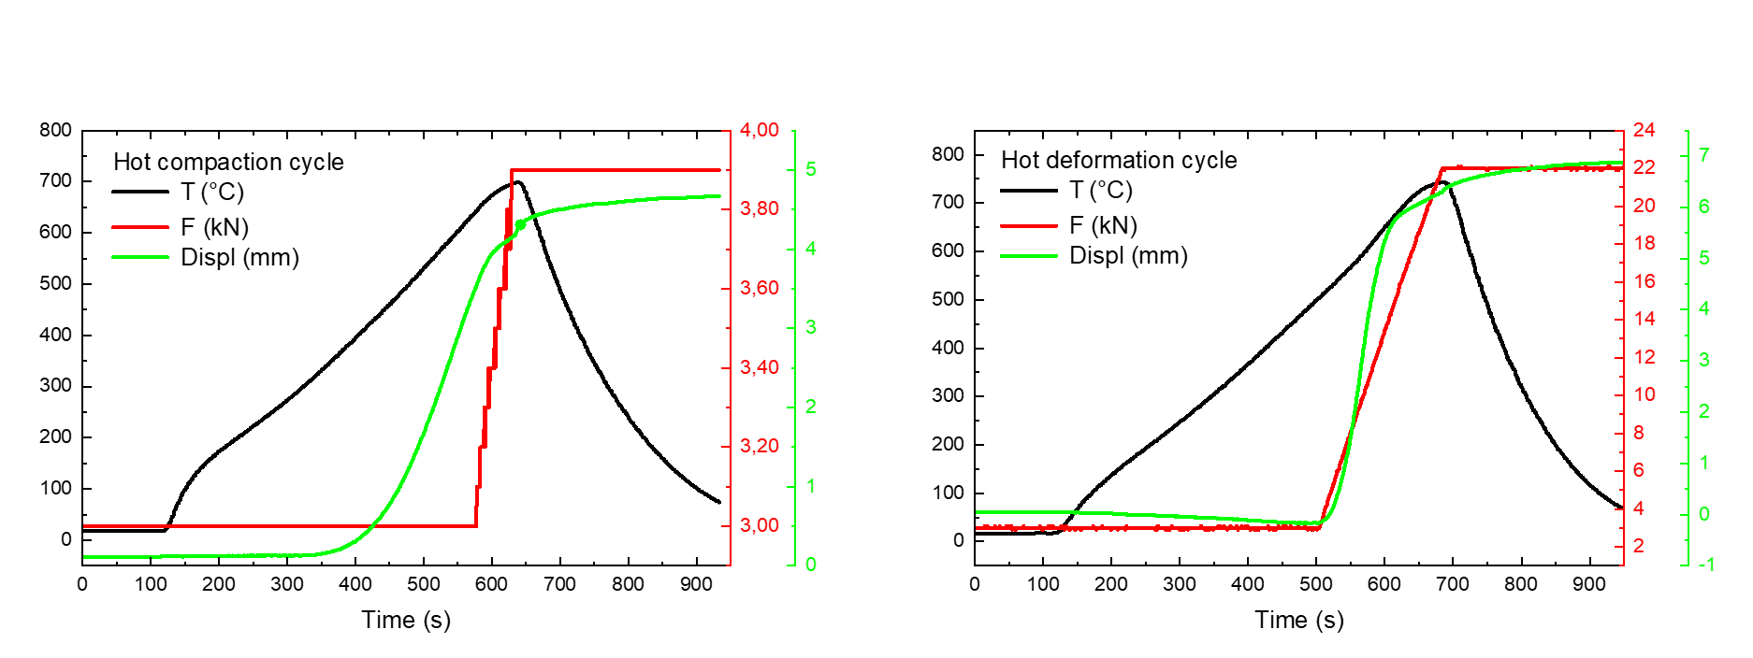
Figure 9: a) Hot compaction cycle of Nd-Fe-B powder (725°C, 48 MPa, 60s) via FAST/SPS. b) Hot deformation cycle of dense Nd-Fe-B samples: pre-heating with 75°C⋅min⁻¹ to 600°C and pre-loaded with 10 MPa before applying the main pressure of 70 MPa and temperature of 750°C.

The pressure during the dwelling step was varied between 50 and 80 MPa in order to obtain better deformation and alignment of the nanocrystalline grains, as shown in Fig. HotDef. Based on the obtained results, it was found, that the pressure of 50 MPa is not enough to fulfil the deformation (only 70% hight reduction by aimed 75%). The sample obtained at 50 MPa has well aligned microstructure in the centre, but high degree of misalignment and cracks in the outer /edge area. The sample obtained at 60 MPa has 73 % hight reduction and well aligned microstructure in most of the volume with small misalignment areas close to the edge. The sample obtained at 70 MPa has 75 % height reduction and well aligned microstructure in the whole sample volume, while the grain growth remains on acceptable level (See Fig. 10 a).
The sample obtained with 80 MPa applied pressure shows a well-aligned but significantly coarse microstructure due to accelerated grain growth possibly enhanced by the improved grains contact and thermal conductivity. Samples hot deformed with 80 MPa at lower temperature (see Table.2 HDS802) demonstrate that grain growth can be controlled by the proper selection of the processing parameters. However, this topic was not further investigated, leaving room for future improvements.

To understand the correlation between the initial sample density and the resulting microstructure, hot deformation was performed also on hot compacted sample with only 90 % density (see Fig 5a).
As already mentioned, the microstructure of dense hot compacted sample, hot deformed at 750°C, 70 MPa is shown on Fig 10 a). The alignment of the nanocrystalline grains (indicated by black arrows), as expected is, perpendicular to the pressing direction (indicated by white arrows) and parallel in both neighbouring flakes. Grain grow is observed in the flake boundary area (indicated by dotted lines). Fig 10 b) represents the microstructure of hot compacted sample with 90% density is, hot deformed at 750°C, 70 MPa. The two neighbouring flakes have well aligned nanocrystalline grains, however not always perpendicular to the pressing direction and parallel to each other. This misalignment can be explained as follow. During the deformation process, the flakes adjacent to the pores do not rotate and slide parallel to the other flakes as described above, but preferably slide into the empty pore space with a rather random orientation. In try to improve the orientation of such flakes hot compacted sample with 90% density was hot deformed at 750°C, 80 MPa and the obtained microstructure is shown on Fig 10 c). As it can be seen, the alignment of the nanocrystalline grains in the two neighbouring flakes are again parallel to each other and perpendicular to the pressing direction. However, the flake boundary area is now broader and the nanocrystalline grains are also bigger due to the grain growth prosses.
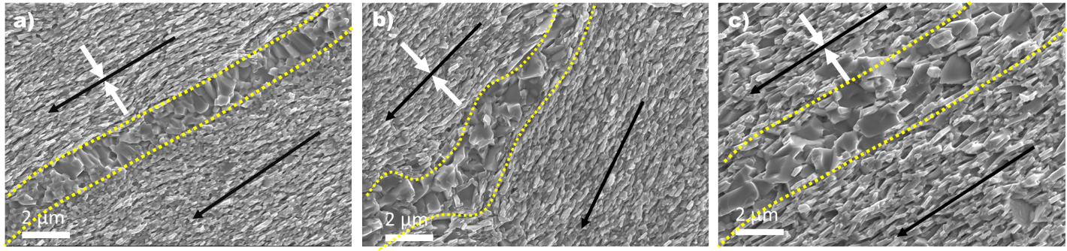
Figure 10: Influence of the hot compacted sample density on the microstructures of hot deformed sample: a.) dense hot compacted sample hot deformed at 750°C, 70 MPa; b.) 90 % hot compacted sample hot deformed at 750°C, 70 MPa; c.) 90 % hot compacted sample hot deformed at 750°C, 80 MPa; The white arrows indicate the pressing direction. Black arrows indicate the alignment direction. The dotted lines indicate the area of grain growth.

3.3 Hot deformation of pre-sintered, porous compacts by Flash SPS
Figure 11 shows representative temperature-power-displacement curves for hot deformation by Flash SPS. All Flash SPS experiments were done starting from porous, pre-sintered Nd-Fe-B compacts (500°C, 50 MPa, 30 s). A typical Flash SPS cycle can be separated into three stages: (I) Pre-heating stage (II) Application of the defined power pulse (III) Free cooling after switching off the power source. Two samples were selected to point out the importance of pre-heating on the deformation in the case of hot deformation by Flash SPS. When pre-heating was done at 251°C, there was no measurable deformation in the pre-heating stage. It is assumed that avoiding any deformation at this stage is coupled with maintaining the primary size of the nanocrystalline grains until the end of stage (I). Therefore, it is expected that formation of the anisotropic microstructure mainly takes place when applying the power pulse. Vice versa, if pre-heating is done at 600°C, a significant deformation of the sample is observed during the pre-heating stage already. It is assumed that in this case – similar to the hot-pressing step during conventional magnet production – rotation of the primary grains, alignment perpendicular to the pressing direction and anisotropic grain growth already starts before applying the power pulse. Under these conditions, at the end of the cycle a more pronounced anisotropy of the grains and a larger grain size are expected even if the main deformation step is done with the same parameters. When looking at the related temperature-power-displacement curves derived in the case of pre-heating with 300°C, 400°C and 500°C (not shown here), it became obvious that deformation in stage (I) already started at a pre-heating temperature of 300°C and – not unexpected – increased with raising temperature. This trend continues in the subsequent deformation during the Flash SPS cycle. When increasing the pre-heating temperature from 251°C, 300°C, 400°C, 500°C to 600°C, the overall height reduction of the samples at the end of the Flash SPS cycle steadily increased from 51.0 %, 63.9 %, 67.6 %, 68.6 % to 71.1 % (see also Table 4).

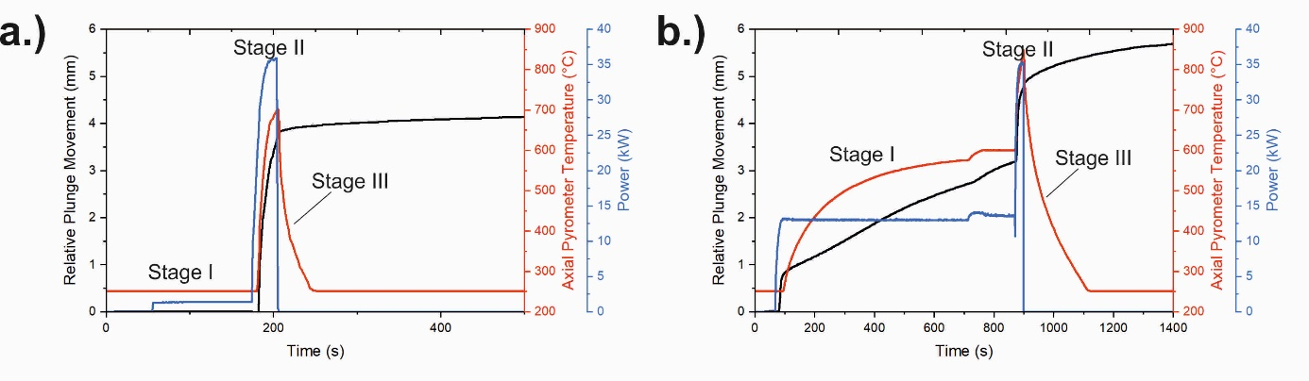
Figure 11. Temperature-power-displacement curves as function of time. The curves show (I) the pre-heating stage, (II) the defined power pulse and (III) the final cooling stage a.) Pre-heating to 251°C, no deformation in stage (I) b.) Pre-heating to 600°C, deformation starts during pre-heating already.

Figure 12a shows a Nd-Fe-B sample after Flash SPS deformation, both in side view and top view. Due to conducting the Flash SPS cycle without an outer die, the edges of the deformed sample were frayed, compromising the exact measurement of the final density. When looking at the microstructure before and after Flash SPS with low magnification, the flake-like shape of the melt-spun Nd-Fe-B starting powder was still clearly visible in both cases (Figure 12b). Almost full densification was achieved in the analysed centre of the sample after Flash SPS. Full densification is coupled with a clearly pronounced height reduction of the former flakes and an alignment perpendicular to the pressing direction. In addition, the interface between former powder flakes was decorated with a Nd-rich secondary phase, which appears bright in the SEM images (Figure 12c). Since the temperature measured in stage II was above 700°C for all samples, it is assumed that the Nd-rich phase is a residue from a transient melting phase formed during Flash SPS [Grieb 1992]. Adjacent to the interface, also a seam of coarse Nd-Fe-B grains appears which are not aligned to the pressing direction. Similar anomalous grain growth is described in the literature for conventionally hot deformed Nd-Fe-B magnets as well. It is explained in the literature that the effect originates from the melt-spinning process and is caused by the lower cooling rate of the upper surface of the flakes [Khlopkov 2007, Sawatzki 2014]. The coarse grains at the interface between former flakes do not contribute to the anisotropic magnetic properties. Furthermore, the fraying of the sample edge is coupled with a strong distortion of the flake alignment near to the edges (related microstructure not shown here), which is another reason for deterioration of the magnetic properties. To exclude this influence in the present study, samples for magnetic measurements were cut from the centre of the samples.

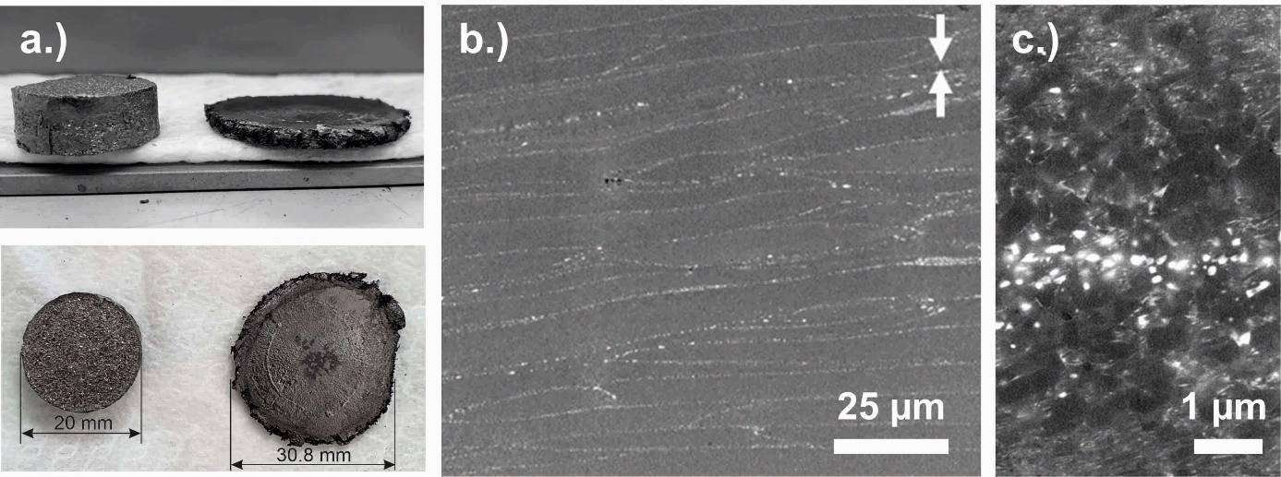
Figure 12: Flash SPS of pre-sintered Nd-Fe-B pellets in a FAST/SPS device a.) Side and top view of a sample hot deformed by Flash SPS without an outer die, before and after deformation (Pre-heating to 600°C, power pulse 35 kW, 32 MPa, 30 s) b.) Microstructure after Flash SPS c.) Nd-rich phase (white dots) and grain coarsening at the interface between adjacent flakes. The white arrows in b.) represent the pressing direction.

As already schematically introduced in Figure 2, achieving well-pronounced anisotropic magnetic properties requires fine-tuning of the microstructure on the nanoscale. Therefore, controlled anisotropic growth and texture of the nanocrystalline grains (see Figure 1c) belong to the main keys to maximize the energy-product of anisotropic Nd-Fe-B magnets. Our study clearly reveals that Flash SPS has the potential to achieve this goal, even if finding the optimum parameter set is quite challenging and requires a comprehensive understanding of the relationship between processing parameters and the resulting microstructure. In this work, we focus on discussing the influence of the pre-heating temperature on anisotropic grain growth. Figure 13 shows the microstructure in the extreme cases, where pre-heating to 251°C and 600°C was applied. The role of pre-heating on the final microstructure is obvious. If deformation of the samples in the pre-heating stage is reliably avoided, primary nanocrystalline grains retain their equiaxed shape until the end of the Flash SPS cycle and show only moderate grain growth (Figure 13a). When pre-heating is done at 600°C, clearly pronounced deformation already in the pre-heating stage also leads to the aspired anisotropic grain growth and texture development (Figure 13b). With respect to the assumption of Hioki [Hioki 2021] that the optimum lateral dimension of the plate-like grains should be in the range of 200 – 500 nm and their height in the range of 20 – 50 nm, this pre-heating condition seems to be already too severe for achieving optimum anisotropic magnetic properties when starting from MQU-F powder. Furthermore, with increasing pre-heating temperature, we found an increasing number of anomalous grains even in the bulk (not shown here), which are expected to deteriorate the magnetic properties. A similar anomalous grain growth was also observed in the fundamental Flash SPS work of Castle et al. [Castle 2017].

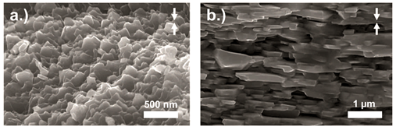
Figure 13: Microstructure of the Nd-Fe-B samples after Flash SPS (power pulse 35 kW, 32 MPa, 30 s) as function of the pre-heating temperature a.) Pre-heating with 251°C b.) Pre-heating with 600°C. The white arrows represent the pressing direction.

3.4 Benchmark of field assisted sintering technologies for the processing of Nd-Fe-B magnets
In general, field assisted sintering techniques like electro discharge sintering, FAST/SPS and Flash SPS enable full densification of the melt-spun Nd-Fe-B powders easily, but do not necessarily lead to a significant anisotropic growth of the nanocrystalline grains. Densification without significant anisotropic grain growth and texture development is indicated if remanence stays near to 0.8. Values below 0.8 hint on inhomogeneous microstructures including weak densified areas and remelted structures as is the case e.g., for EDS samples [Leich 2018] or on residual porosity [Croat 2018] as is the case e.g., for the FAST/SPS samples pre-sintered at 500°C. On the other hand, the coercivity enables to conclude on the grain growth when applying these techniques. In the FAST/SPS sample sintered at 500°C, almost no growth of the nanocrystalline grains during pre-sintering is indicated due to the coercivity stays in the same range as in the starting powder (see Table 4). Therefore, starting the sintering cycle from nanocrystalline grains, the size of which is near to their original size in the starting powder, enabled to conclude on the anisotropic grain growth as function of the field assisted sintering parameters. When increasing the FAST/SPS temperature to 800°C, full densification is accompanied by significant isotropic grain growth as indicated by the clear decrease of the coercivity [Mishra 2023]. Therefore, in the present study temperature and pressure were decreased to 725°C and 45 MPa when aiming on full densification of the pre-sintered compacts. In sum, our results and related results from literature [Wüst 2015, Wang 2015] demonstrate that hot pressing and FAST/SPS are complementary techniques for producing isotropic Nd-Fe-B magnets from melt-spun powders.

For benchmarking our results with respect to producing textured Nd-Fe-B magnets with well-pronounced anisotropic magnetic properties, Figure 14 compares the demagnetization curves of selected samples produced in this study. As reference, the demagnetization curve of a commercial Nd-Fe-B magnet made by our industrial partner WILO is shown, which is produced from MQU-F powder by the established hot pressing and die-upsetting. As already mentioned before, hot deformed Nd-Fe-B magnets should combine a coercivity higher than 1300 kA⋅m⁻¹ and a remanence higher than 1.3 T for becoming competitive to the industrial standard. When comparing the magnetic properties of the commercial anisotropic Nd-Fe-B magnet and the anisotropic Nd-Fe-B magnets produced field assisted sintering technologies, it becomes obvious that these technologies have the potential to become competitive, but further parameter optimization and adaption of plant technology are necessarily required for implementing these technologies in an industrial production line.

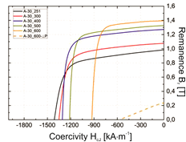
Figure 14: Magnetic properties of anisotropic Nd-Fe-B magnets as function of the processing conditions. The Nd-Fe-B magnets were produced by hot deformation via a.) high-pressure FAST/SPS starting from porous, pre-sintered compacts b.) FAST/SPS starting from dense, pre-sintered compacts c.) Flash SPS starting from porous, pre-sintered compacts d.) Commercial Nd-Fe-B magnet made by hot pressing and hot deformation by die-upsetting.

Benchmark of FAST/SPS: Our first FAST/SPS attempt, where we started from porous, pre-sintered compacts, still has a preliminary character. Even when a high densification of around 96 % at 700°C and 50 MPa is achieved, the magnetic properties remained isotropic hinting on the absence of texture. Increasing the temperature to 800°C while keeping the pressure constant, slightly improved the remanence, but significant decrease of coercivity indicated the onset of anomalous grain growth. Increasing the pressure to 500 MPa further increased the remanence to 1.25 T, but longer dwell time at 800°C for achieving this pressure were counterproductive for the coercivity. Therefore, the results confirm the expected positive influence of high pressures for microstructure texturing, but the applied temperature of 800°C was too high to reliably avoid anomalous grain growth. Furthermore, it can be concluded that high pressure up to 500 MPa does not prevent this grain growth.

Significantly better results were achieved in our second FAST/SPS attempt, where dense, pre-sintered compacts were used for hot deformation. Here we would like to emphasise again that the deformation experiments were done in closed die geometry, where the hight reduction is also fixed. As discussed above, the fixed volume helps to obtain nicely shaped, cracks free, hot deformed samples but only if the hight reduction is achieved. Therefore, the effect of the hight reduction on the microstructure and the magnetic properties was not investigated in details in this work. At the same time, increasing of the applied pressure over certain level accelerates the grain growth process and worsens the magnetic properties. It can be possible that this can be compensated by lowering the compaction temperature.
On Fig. HeightReduction, the development of the magnetic properties of the best performing samples during all stages are presented. The magnetic properties of the initial MQU-F powder were measured on spherical specimens of isotropic powder mixed with 5 wt. % of epoxy resin. The magnetic properties of all other samples were measure on rectangular specimen, cut from the sample centre with typical dimension of 1 x 2.5 x 2 mm (2 mm along the hard axis). All curves were corrected for with the corresponding demagnetisation factor. The step-like change in the magnetisation loop of the initial isotropic MQU-F powder indicated the presence of a certain amount of amorphous phase. The magnetisation curve of the hot deformed sample indicates that during the hot compaction those amorphous phase crystallizes during the processing (as shown in Fig. HotDeformed a) and remain isotropic. As result the coercivity is slightly improved, while the saturation magnetization remains unchanged, which also confirms that grain growth during the compaction process was avoided (Fig HightReduction). During the hot deformation process anisotropy is induced by the deformation of the nanocrystalline grains and alignment of the melt spun flakes (see Fig HotDeformed). As result the coercivity is reduced by ca. 20%, while the saturation magnetization is increased by ca. 32%. These values are directly connected with the degree of deformation defined by hight reduction induced to the sample. On Fig. HightReduction b) the magnetisation loops measure on samples with different degree of hight reduction produced by the FAST SPS [this work] and HP [Sawatzki 2016] are compered. As it can be seen, the FAST SPS samples have the same performance (B_{r} = 1.22 T, H_{ci} = 1438 kA⋅m⁻¹, and (BH)_{max} = 305 kJ⋅m⁻³ and B_{r} = 1.38 T, H_{ci} = 1180 kA⋅m⁻¹, and (BH)_{max} = 325 kJ⋅m⁻³ for 50 and 75 % height reduction) as the HP samples, but with higher degree of deformation. his effect can be interesting from applications point of view and need some further investigation. One possible explanation can be the different way pressure is applied during both processes. In FAST SPS the applied pressure is constantly increasing, while in HP the applied pressure is varied in a way to ensure constant displacement speed (deformation rate).

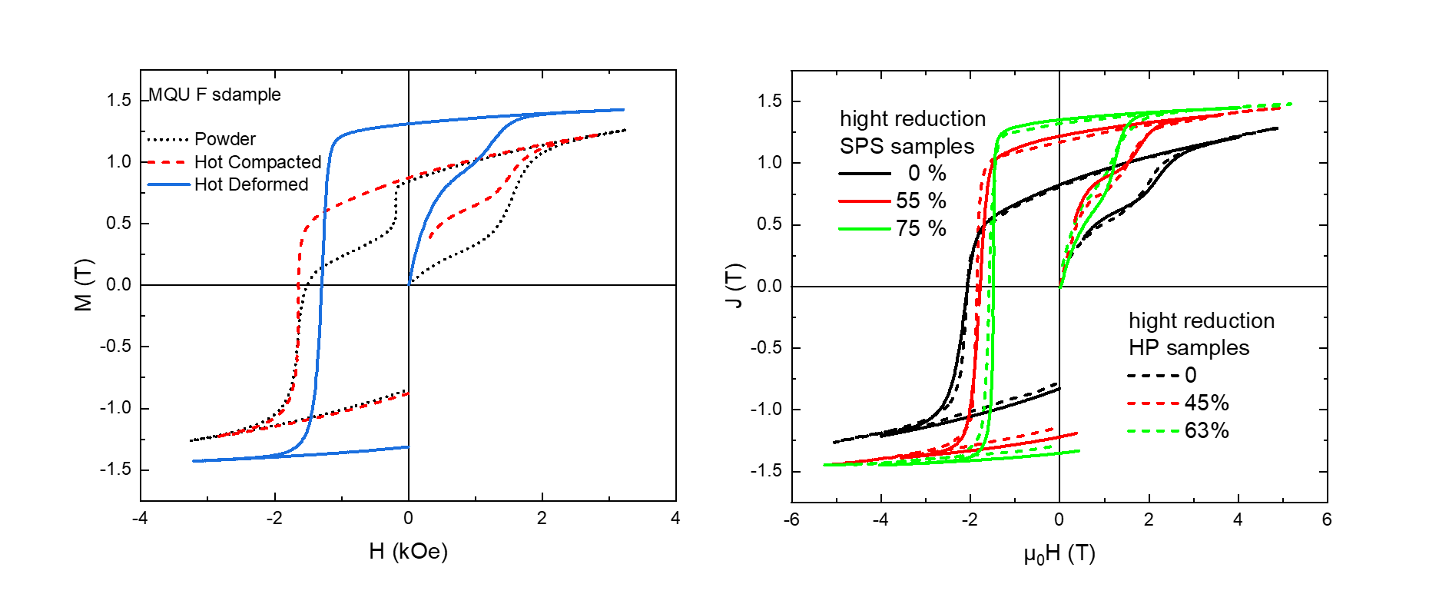
In the literature, the best results of hot deformation by FAST/SPS were achieved by Liu et al. [Liu 2010] and Wang et al. [Wang 2015]. Liu et al. did the hot deformation of a MQP-UG powder at 400 MPa and 700°C, achieving a height reduction of 80 %. The magnetic properties were B_{r} = 1.492 T, H_{ci} = 1004 kA⋅m⁻¹, and (BH)_{max} = 400 kJ⋅m⁻³. Wang et al. did the hot deformation of a MQP-F powder at 500 MPa and 700°C, resulting in a height reduction of 70 %. The authors reported magnetic properties of B_{r} = 1.14 T, H_{ci} = 1227.9 kA⋅m⁻¹, and (BH)_{max} = 383.9 kJ⋅m⁻³. In this study of Wang et al., it has been demonstrated that the current pulse ratio (CPR) is an additional influence factor for tuning the magnetic properties. Magnets prepared with a CPR of 2:2 (= pulse length of 6.6 ms) outperformed the performance of magnets prepared with a CPR of 12:2 (= pulse length 39.6 ms). In the latter case, the properties were slightly lower with B_{r} = 1.11 T, H_{ci} = 1205.6 kA⋅m⁻¹, (BH)_{max} = 352.2 kJ⋅m⁻³. The authors argued that the amount of partial liquid phase during deformation is reduced with shorter pulse length reducing the decomposition of the Nd₂Fe₁₄B phase during hot deformation.

Benchmark of Flash SPS: An advantage of doing the hot deformation by Flash SPS is the possibility to achieve large deformation degrees and pronounced anisotropic magnetic properties at very moderate load (32 MPa) hinting on the occurrence of electroplasticity as additional deformation mechanism. Our results reveal that the pre-sintering conditions as well as the kind of pre-heating play a distinct role for the microstructure texturing during Flash SPS. In the present work, we achieved the best remanence of 1.39 T and energy product (BH)_{max} of 364 kJ⋅m⁻³ for the sample pre-heated to 600°C, which shows the general potential of Flash SPS for producing high performance permanent magnets. However, a coercivity of only 927 kA⋅m⁻¹ of this sample indicates the onset of anomalous grain growth, which was confirmed by microstructure analysis. Recently, Maccari et al. reported retarded anomalous grain growth of the same material system by increasing the dwell time for pre-sintering of the porous compact from 30 s to 120 s [Maccari 2023]. The authors explained the effect by the formation of better pronounced sintering necks between primary grains, which they supposed to retard the grain growth during the subsequent Flash SPS cycle. Reduced anomalous grain growth was confirmed by microstructure analysis. As final result of this study, the magnetic properties were better balanced with B_{r} = 1.37 T, H_{ci} = 1195 kA⋅m⁻¹, and (BH)_{max} = 351 kJ⋅m⁻³. These results clearly outperform the results of the initial Flash SPS study done by Castle et al. starting from MQU-F powder as well and achieving a B_{r} = 1.16 T, H_{ci} = 1438 kA⋅m⁻¹, and (BH)_{max} = 230 kJ⋅m⁻³ [Castle 2017].

4. Conclusions
The present work demonstrates that field assisted sintering technologies (FAST/SPS and Flash SPS) can compete with the established processing route for hot deformed anisotropic Nd-Fe-B magnets, which contains hot pressing and subsequent die-upsetting. It is assumed that electroplasticity as additional deformation mechanism has a positive influence on deformation and anisotropic grain growth, but doubtless proof of this assumption is still lacking. FAST/SPS and Flash SPS can be preferentially applied for plate-shaped magnets. Ring magnets with preferred magnetic orientation along the c-axis are difficult to achieve with both technologies, requiring further tooling development and processing optimization.

Our results reveal that Nd-Fe-B magnets, which were hot deformed by FAST/SPS, approach or even exceed the properties of commercial anisotropic Nd-Fe-B magnets. The best performance was achieved with a Nd-Fe-B magnet, which was pre-sintered by FAST/SPS (75 K⋅min⁻¹, 725°C, 45 MPa, 1 min) to almost theoretical density and then hot deformed at 70 MPa, 750°C with a height reduction of 75 %. The magnet had a B_{r} = 1,38 T, H_{ci} = 1180 kA⋅m⁻¹, and (BH)_{max} = 305 kJ⋅m⁻³, which exceeded the performance of a commercial magnet of our industrial partner WILO (B_{r} = xxx T, H_{ci} = xxx kA⋅m⁻¹, and (BH)_{max} = xxx kJ⋅m⁻³). A specific challenge of FAST/SPS devices is the need of applying a pre-load to ensure sufficient electrical contact. Therefore, samples must be necessarily pre-sintered when conducting hot-deformation in a FAST/SPS device. Our study reveals that pre-sintering to almost theoretical density is – similar to conventional magnet production by hot pressing and die-upsetting – preferred for achieving homogeneous deformation and reliably avoiding cracks at the edges. Another challenge is to avoid anomalous grain growth during pre-sintering as well as during hot deformation. The risk of anomalous grain growth is significantly enhanced if the FAST/SPS temperature clearly exceeds 700°C. Contrarily, temperatures beyond 700°C are advantageous when aiming on full densification in the shortest possible time. Therefore, fine tuning of temperature and dwell time is an absolute must. Our studies show that the applied pressure promotes anisotropic grain growth, but does not prevent anomalous grain growth if the temperatures become too high. Furthermore, we found that even high heating rates up to 400 K⋅min⁻¹ (results not shown here) did not improve the situation significantly if FAST/SPS cycles are conducted in the critical temperature range.

Hot deformation by Flash SPS enables to approach the properties of commercial anisotropic Nd-Fe-B magnets as well. The best compromise of magnetic properties was achieved in the recent study of Maccari et al. demonstrating balanced magnetic properties of B_{r} = 1.37 T, H_{ci} = 1195 kA⋅m⁻¹, and (BH)_{max} = 351 kJ⋅m⁻³ [Maccari 2023]. Flash SPS offers some features which are difficult to achieve with conventional die-upsetting. One important aspect is the possibility to start the process from highly porous parts, which aids in achieving high deformation degrees at moderate loads. Recently, we demonstrated that this option is especially attractive for the direct recycling of scrap from hot deformed Nd-Fe-B magnets containing coarse fragments with sizes in the range of 125 – 1000 µm [Mishra 2023, Keszler 2023]. Coarse fragments are preferentially suitable for direct recycling of magnet scrap due to keeping the oxygen contamination low. Such fragments cannot be processed by conventional hot pressing and die-upsetting. In general, direct recycling of magnet scrap is attractive from energetic point of view due to avoiding costly remelting or separation technologies. A specific challenge of the dynamic Flash SPS process is the accurate process control. Furthermore, demonstration of producing net-shaped magnets by Flash SPS is still pending.

In general, there are still some hurdles to overcome before field assisted sintering technologies can be applied for industrial magnet production. The established die-upsetting process is optimized in a way that the hot-pressing step and the sub-sequent die-upsetting step can be done fully automated in less than 30 s for each step by using pre-heated hot pressing and die-upsetting tools as well as suitable manipulator systems. Overall cycle times used in the present study clearly exceed the cycle times of standard magnet production. Hot pressing and die-upsetting tools are made of high-temperature resistant alloys, which are expensive. On the other hand, the cost factor is balanced by a long-term operation ability not accessible with graphite tools preferentially used for field assisted sintering technologies so far. Furthermore, in the standard magnet production, all operations are done in air, while field assisted sintering technologies usually require a vacuum chamber enabling to conduct the pre-sintering and hot deformation under vacuum or protective atmosphere. This measure is important to avoid severe oxidation of tools and powder. Implementation of protective atmosphere conditions complicates automated production and makes it more expensive. Furthermore, a comprehensive analysis of the energy consumption for the different field assisted sintering technologies is still lacking.

Acknowledgements
This work was supported by the German Research Foundation (DFG) under the grant numbers BR3418/1-2 and GU514/8-2. Furthermore, parts of the work were done in the framework of the project “EnerGieeffiziENtE KreiSlaufwirtschaft krItischer RohStoffe GENESIS” funded by the German Ministry of Economic Affairs and Climate Action (BMWK), Förderkennzeichen 03EI5009D according to a decision of the German Federal Parliament. The work performed at Fraunhofer IWKS was supported by BMWK in the frame of the RecycleTeam project. The funding and the experimental support of Ralf Steinert are highly acknowledged.

References
[Campos 2014] M.A. Campos, N. Vicente, I.F. Machado, K. de Souza K, D. Rodrigues, M.F. de Campos, NdFeB Type Magnets Produced by Spark Plasma Sintering. Mat. Sci. Forum 802 (2014) 585 – 589.
[Castle 2017] E. Castle, R. Sheridan, W. Zhou, S. Grasso, A. Walton, M.J. Reece, High coercivity, anisotropic, heavy rare earth-free Nd-Fe-B by Flash Spark Plasma Sintering, Sci. Rep. 7 (2017) 11134.
[Croat 2018] J.J. Croat, Rapidly Solidified Neodymium-Iron-Boron Permanent Magnets, Woodhead Publishing Series in Electronic and Optical Materials, Elsevier, 2018.
[Dimitrov 2022] N.K. Dimitrov, Y. Liu, M.F. Horstemeyer, Electroplasticity: A review of mechanisms in electro-mechanical coupling of ductile metals, Mech. Adv. Mater. and Structure 5 (2022) 705 – 716.
[Fais 2020] A. Fais, Electro-Sinter-Forging: the fastest FAST, Presentation on 17th FAST/SPS expert meeting, Dec 09, 2020, online.
[Gopalan 2009] R. Gopalan, H. Sepehri-Amin, K. Suresh, T. Ohkubo, K. Hono, T. Nishiuchi, N. Nozawac, S. Hirosawa, Anisotropic Nd–Fe–B nanocrystalline magnets processed by spark plasma sintering and in situ hot pressing of hydrogenation–decomposition–desorption–recombination powder, Scripta Mat. 61 (2009) 978 – 981.
[Grasso 2014] S. Grasso, T. Saunders, H. Porwal, O. Cedillos-Barraza, D. D. Jayaseelan, W.E. Lee, M.J. Reece, Flash Spark Plasma Sintering (FSPS) of Pure ZrB₂, J. Am. Ceram. Soc. 97 (2014) 2405 – 2408.
[Grieb 1992] B. Grieb, E.-Th. Henig, G. Schneider, G. Knoch, G. Petzow, D. de Mooij, Powder Metall. 35 (1992) 221 – 227.
[Grünberger 1997] W.Grünberger, D.Hinz, A.Kirchner, K.H.Müller, L.Schultz, Hot deformation of nanocrystalline Nd-Fe-B alloys, J. Alloy. Compd. 257 (1997) 293–301.
[Gutfleisch 2000] O. Gutfleisch, Controlling the properties of high energy density permanent magnetic materials by different processing routes, J. Phys. D 33 (2000) R157–R172.
[Gutfleisch 2011] O. Gutfleisch, M.A. Willard, E. Brück, C.H. Chen, S.G. Sankar, J. Ping Liu, Magnetic Materials and Devices for the 21st Century: Stronger, Lighter, and More Energy Efficient, Adv. Mater. 23 (2011) 821–842.
[Hioki 2021] K. Hioki, High performance hot-deformed Nd-Fe-B magnets (Review), Sci. Techn. Adv. Mat. 22 (2021) 72 – 84.
[Hu 2011] Z. Hu, L. Chu, J. Li, Y. Liu, Enhanced magnetic properties in Nd-Fe-B magnets prepared by spark plasma sintering via die-upsetting process, Journal of Rare Earths 29 (2011) 660 – 663.
[Huang 2012] Y.L. Huang, Z.W. Liu, X.C. Zhong, H.Y. Du, D.C. Zeng, NdFeB based magnets prepared from nanocrystalline powders with various compositions and particle sizes by spark plasma sintering, Powder Metall. 55 (2012) 124–129.
[Khlopkov 2004] K. Khlopkov, O. Gutfleisch, R. Schäfer, D. Hinz, K.-H. Müller, L. Schultz, Interaction domains in die-upset NdFeB magnets in dependence on the degree of deformation, Journal of Magnetism and Magnetic Materials 272-276 (2004) E1937 – E1939.
[Khlopkov 2007] K. Khlopkov, O. Gutfleisch, D. Hinz, K.-H. Müller, L. Schultz, Evolution of interaction domains in textured fine-grained Nd₂Fe₁₄B magnets, J. Appl. Phys. 102 (2007) 023912.
[Leich 2018] L. Leich, A. Röttger, W. Theisen, M. Krengel, Densification of nanocrystalline NdFeB magnets processed by electro-discharge sintering – Microstructure, magnetic, and mechanical properties, J. Magn. Magn. Mat. 460 (2018) 454–460.
[Leich 2019] L. Leich, A. Röttger, M. Krengel, W. Theisen, Recycling of NdFeB Magnets by Electrodischarge Sintering—Microstructure, Magnetic, and Mechanical Properties, J. Sustain. Metall. 5 (2019) 107-117.
[Liu 2012] Z.W. Liu, Y.L. Huang, H.Y. Huang, X.C. Zhong, H.Y. Yu, D.C. Zeng, Isotropic and Anisotropic Nanocrystalline NdFeB-Based Magnets Prepared by Spark Plasma Sintering and Hot Deformation. Key Eng. Mat. 510 – 511 (2012) 307 – 314.
[Mishra 1990] R.K. Mishra, T.Y. Chu, L.K. Rabenberg, The development of the microstructure of die-upset Nd-Fe-B magnets, J. Magn. Magn. Mater. 84 (1990) 88–94.
[Mishra 2023] T. Prasad Mishra, L. Leich, M. Krengel, S. Weber, A. Röttger, M. Bram, NdFeB Magnets with Well-Pronounced Anisotropic Magnetic Properties Made by Electric Current-Assisted Sintering, Adv. Eng. Mat. 25 (2023) 2201027.
[Keszler 2023] M. Keszler, F. Grosswendt, A.-C. Assmann, M. Krengel, F. Maccari, O. Gutfleisch, D. Sebold, O. Guillon, S. Weber, M. Bram, Direct recycling of Nd-Fe-B magnet scrap by field assisted sintering technologies, Adv. Energy Sustainability Res. (2023) 2300184.
[Ruszkiewicz 2017] B. Ruszkiewicz, T. Grimm, I. Ragai, L. Mears, J.T. Roth, A Review of Electrically-Assisted Manufacturing With Emphasis on Modeling and Understanding of the Electroplastic Effect, J. Manufact. Sci. Eng. 139 (2017) 110801.
[Sawatzki 2014] S. Sawatzki, I. Dirba, H. Wendrock, L. Schultz, O. Gutfleisch, Diffusion processes in hot-deformed Nd–Fe–B magnets with DyF₃ additions, J. Magn. Magn. Mat. 358-359 (2014) 163 – 169.
[Simon 2019] D. Simon, H. Wuest, S. Hinderberger, T. Koehler, A. Marusczyk, S. Sawatzki, L.V.B. Diop, K. Skokov, F. Maccari, A. Senyshyn, H. Ehrenberg, O. Gutfleisch, Structural and magnetic properties of Ce_{1−x}Sm_{x}Fe1_{1−y}Ti₁V_{y}, Acta Mat. 172 (2019) 131-138.
[Song 2013] J. Song, M.Yue, J.Zuo, Z.Zhang, W.Liu, D.Zhang, J.Zhang, Z.Guo, W.Li, J. Rare Earths 31 (2013) 674–678.
[Sugimoto 2011] S. Sugimoto, J. Phys. D: Appl. Phys. 44 (2011) 64001.
[Tomše 2020] T. Tomše, Z. Samardžija, L. Scherf, R. Kessler, S. Kobe, K. Žužek Rožman, S. Šturm, A spark plasma sintering approach to the manufacture of anisotropic Nd-Fe-B permanent magnets, Journal of Magnetism and Magnetic Materials 502 (2020) 166504.
[Tomše 2021] T. Tomše, J. Jaćimović, J.-M. Dubois, S. Kobe, K. Žužek Rožman, S. Šturm, Nanostructured multicomponent Nd-Fe-B magnets prepared by a spark-plasma-sintering approach, Journal of Magnetism and Magnetic Materials 533 (2021) 168011.
[Wang 2015] T. Wang, M. Yue, Y. Li, M. Tokita, Q. Wu, D. Zhang, J.Zhang, Tuning of Microstructure and Magnetic Properties of Nanocrystalline NdFeB Permanent Magnets Prepared by Spark Plasma Sintering, IEEE Magnetics Letters 6 (2015) 1–4.
[Wuest 2015] H. Wuest, L. Bommer, T. Weißgärber, B. Kieback, Magnetic and structural properties of spark plasma sintered nanocrystalline NdFeB-powders, J. Magn. Magn. Mat. 392 (2015) 74 – 78.
[Yang 2017] Y. Yang, A. Walton A, R. Sheridan, K. Güth, R. Gauß, O. Gutfleisch, M. Buchert, B.-M. Steenari, Tom Van Gerven, P.T. Jones, K. Binnemanns, REE Recovery from End-of-Life NdFeB Permanent Magnet Scrap: A Critical Review, J. Sustain. Metall. 3 (2017) 122–149.
[Zhao 2021] J. Zhao, C. Hu, Z. Zhao, M. Tang, X. Tang, Effects of deformation degree on the magnetic properties of soft magnetic steel after heat treatment. Journal of Magnetism and Magnetic Materials 533 (2021) 167991.

